Lincoln Elementary Supply Lists
2023-2024
*Supplies will be provided to students who are in need of support.
Preschool  - A back pack large enough to hold a folder  - roll of paper towels  - 1 Large container of Clorox wipes  - bottle of sanitizer  - 2 boxes of tissues  - 1 box of large Ziplock bags  - 1 change of clothes in a bag with your child’s name on it (including socks and underwear)  - 1 blanket to be used at rest time  - 1 picture of family to be used for a special project  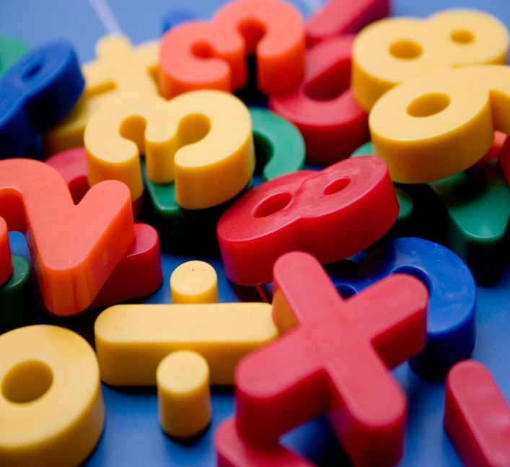 | Kindergarten  For individual Students  - Headphones  - Water bottle  - Extra Pair of Clothes  Classroom Community Wish List Donations  (Not Required)  - Tissues  - Ziploc Bags (Gallon, Quart, Sandwich, and Snack size)  - Baby Wipes  - Paper Plates  - Napkins  - Paper Bowls
First Grade  For individual Students  - Dry erase markers  - Pencil case  - Crayons  - Glue stick  - Scissors  - Homework folder  - Headphones  - Highlighter  - Markers  - Water bottle  Classroom Community Wish List Donations (Not Required)  - Clorox Wipes  - Tissues  - Hand Sanitizer  - Paper Plate (large and small)  - Cotton Balls  - Zip lock bags (large and small)  - Tissue paper  - Sharpie Markers  - Post-it notes  - Cups (5 oz)  - Colored Cardstock  - Duct Tape  - Popsicle sticks  - Pipe cleaners | Second Grade  For individual Students  - 16 or 24 pack of Crayola crayons  - 1 highlighter  - 2 large glue sticks  - 4 dry erase markers and eraser  - 1 set of headphones  - 1 pink eraser  - 4 pocket folders (1 for each quarter)  Classroom Community Wish List Donations  (Not Required)  - 2 boxes of tissues  - 1 bottle of hand sanitizer  - 1 container of disinfecting wipes
Third Grade  Individual School Supplies  - Backpack  - Headphones  - 2-Pocket Folder  - Pencil Box  - Multiplication Flashcards  Classroom Community Wish List Donations  (Not Required)  - 2 boxes of tissues  - 1 container sanitizing wipes  - 2 bottles hand sanitizer  - Quart size storage bags  - Pencil top erasers  - Sidewalk Chalk (recess)  - Bubbles (recess)  - Dry Erase Markers | Fourth/Fifth Grade  Individual Student supplies  - 2 folders  - 1 pack of crayons (16 or 24 pack)  - 1 pack of colored pencils  - 1 set of headphones  - 1 pair of student scissors  Classroom Community Wish List Donations  (Not Required)  - 3 boxes of tissues  - 1 pack of sanitizing wipes  